|  |  |
| --- | --- |
| **EWULogo.png Mn nh** | **EAST WEST UNIVERSITY** |
| **Department of Computer Science and Engineering** |
| **B.Sc. in Computer Science and Engineering Program** |
| **Mid Term II, Fall 2021** |

|  |  |
| --- | --- |
| **Course:** | **CSE246 (Algorithms), Section - 1** |
| **Instructor:** | **Taskeed Jabid** |
| **Full Marks:** | **20** |
| **Time:** | **1 Hour and 20 Minutes + 10 Minutes** |

**Note:** There are Four questions, answer ALL of them.

1. Writer down the pseudocode to solve Rock Climbing problem with some variation. The variation is: whenever climber go one-step in left diagonal direction, it added 20% extra risk with the diagonal position’s risk value (because climber is a right-hander). Considering this variation write down the modified pseudocode.
2. Show with some sample matrix dimension that order of carrying multiplication will affect the total cost matrix chain multiplication. The recurrence relation for solving matrix chain multiplication is

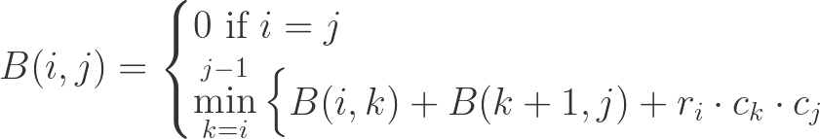

Explain why this recurrence relation solves the problem

1. Write down the LCS table (consisting both length and direction) of two strings of tour own choice. You have to choose string so that both strings must be at least 6 characters long and also LCS length should be at least 3.
2. Show with some example data that greedy approach for solving 0/1 knapsack problem will fail. Write down the full table if you are provided 4 items with some weight and value (Choose weight and value of the items on your own). Choose the knapsack size any number between 8-10